Data Collection

|  |  |
| --- | --- |
| **Date** | 09 November 2022 |
| **Team ID** | PMT2022TMID09735 |
| **Project Name** | Real-Time Communication System Powered by AI for Specially abled |

CREATE TRAIN AND TEST FOLDERS

Conversation engine for deaf and dumb:

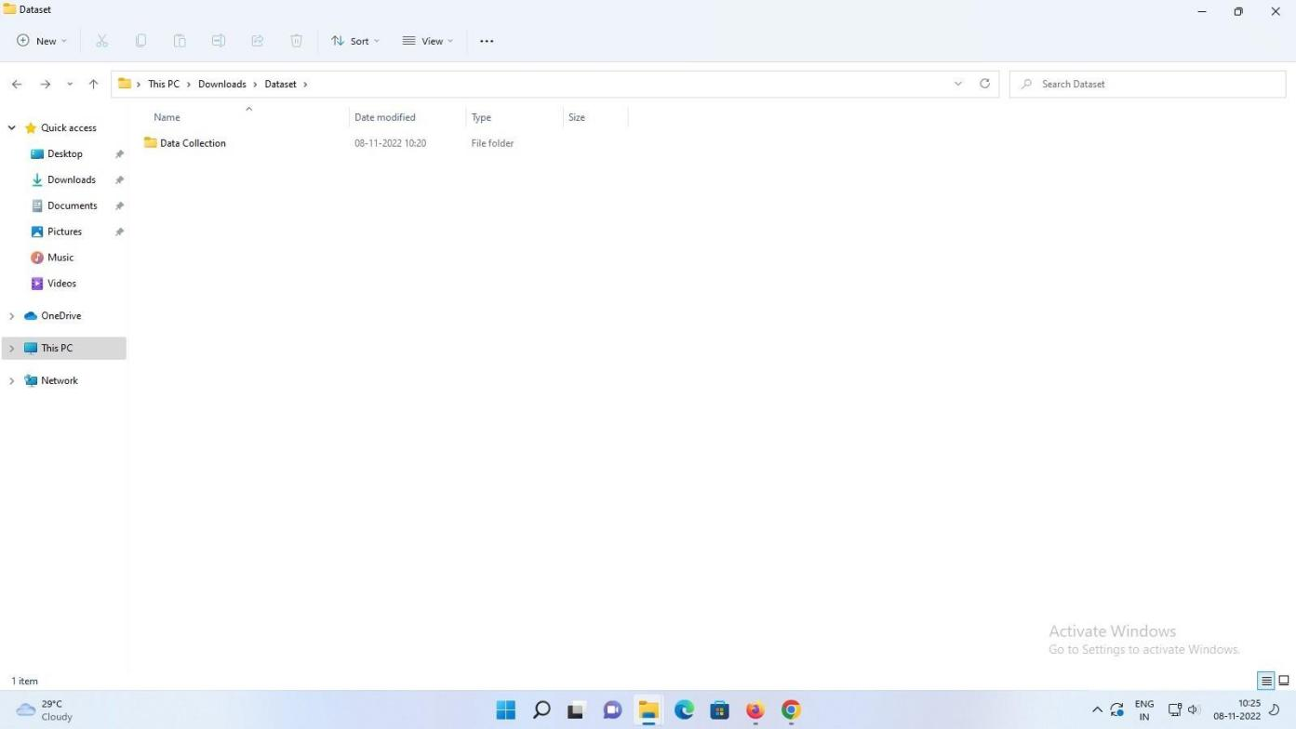

Data collection:

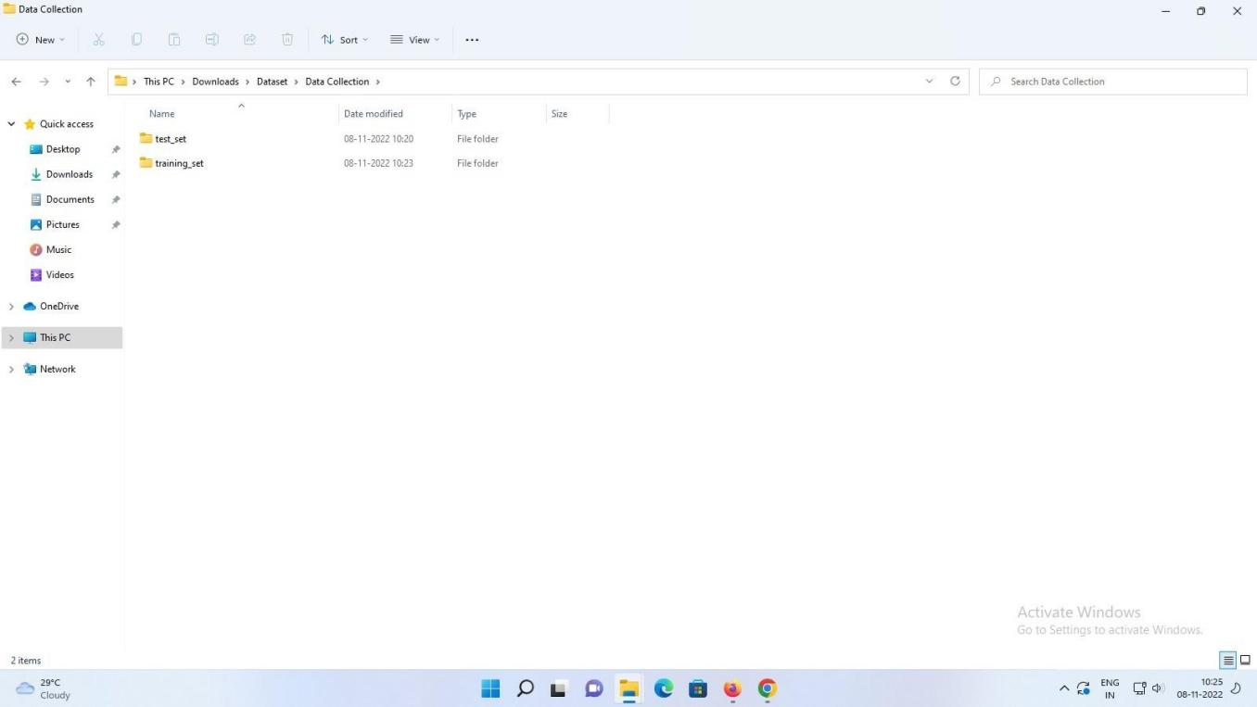

Training set:

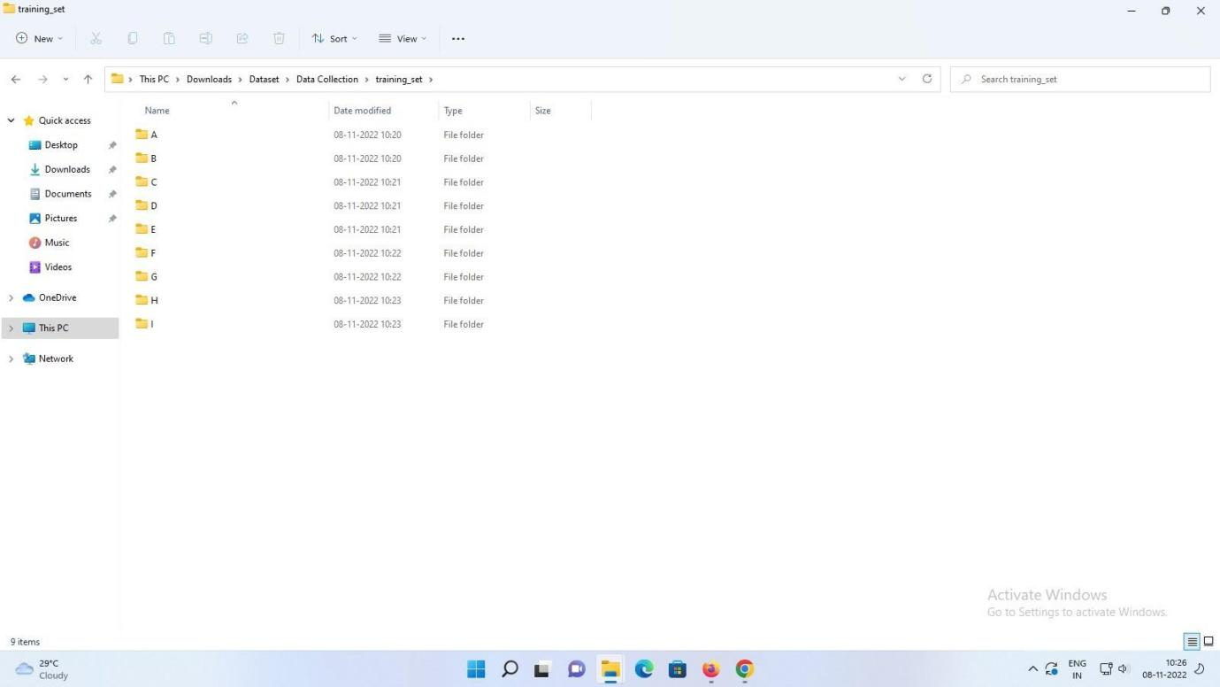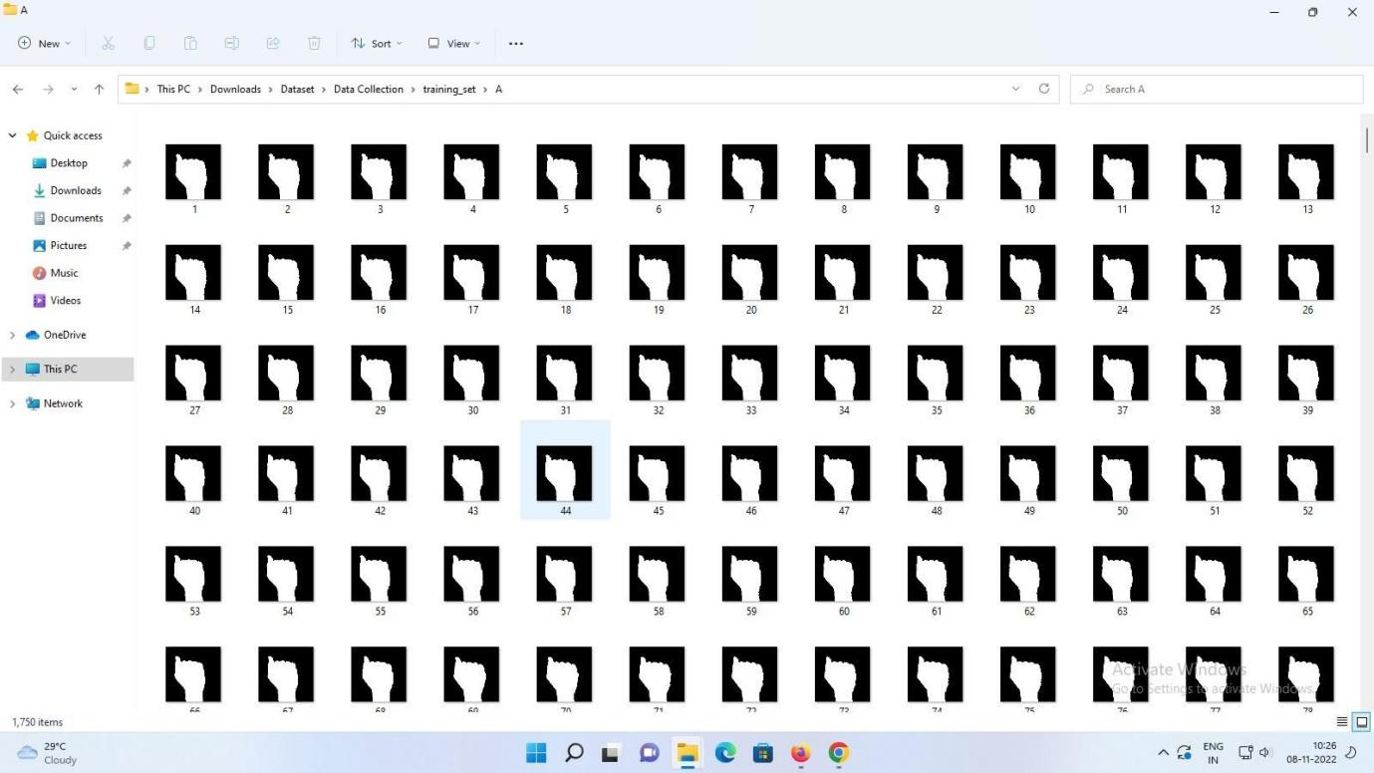

Test set:

